Code2.R
arahisan
2026-04-22
library(tidyverse)
library(psych)
library(caret)
library(skimr)
library(readxl)
library(dplyr)
suppressWarnings(
gtd_data <- read_excel("globalterrorismdb_0221dist.xlsx")
)
# Clean df
gtdclean <- gtd_data %>%
select(
eventid, iyear, imonth, approxdate, nkill, nwound, property, propextent, crit1, crit2,
crit3, region, region_txt, attacktype1, attacktype2,
attacktype3, weaptype1, weaptype2, weaptype3, targtype1,
claimed, success, attacktype1_txt, weaptype1_txt, weaptype2_txt, weaptype3,
extended, resolution, country, country_txt, provstate, city, latitude, longitude,
specificity, vicinity, location, summary, doubtterr, alternative, alternative_txt,
multiple, suicide, attacktype2_txt, attacktype3_txt,targtype1_txt, targsubtype1,
targsubtype1_txt, corp1, target1, natlty1, natlty1_txt, gname, gname2, motive, nperps,
claimed, ishostkid, nhostkid, nhours, ndays, ransom
)
gtdclean <- gtdclean %>%
filter(!is.na(nkill) & !is.na(nwound))
kill_thresh <- quantile(gtdclean$nkill, 0.997, na.rm = TRUE)
wound_thresh <- quantile(gtdclean$nwound, 0.997, na.rm = TRUE)
gtdclean <- gtdclean %>%
filter(nkill <= kill_thresh & nwound <= wound_thresh)
# Data points
dim(gtdclean)
## [1] 180674 60
skim(gtdclean)
Data summary
Name | gtdclean
Number of rows | 180674
Number of columns | 60
_______________________
Column type frequency:
character | 20
logical | 2
numeric | 37
POSIXct | 1
________________________
Group variables | None
Variable type: character
skim_variable | n_missing | complete_rate | min | max | empty | n_unique | whitespace
approxdate | 170538 | 0.06 | 3 | 46 | 0 | 2797 | 0
region_txt | 0 | 1.00 | 9 | 27 | 0 | 12 | 0
attacktype1_txt | 0 | 1.00 | 7 | 35 | 0 | 9 | 0
weaptype1_txt | 0 | 1.00 | 5 | 75 | 0 | 12 | 0
weaptype2_txt | 168122 | 0.07 | 5 | 75 | 0 | 11 | 0
country_txt | 0 | 1.00 | 4 | 32 | 0 | 201 | 0
provstate | 0 | 1.00 | 2 | 39 | 0 | 2544 | 0
city | 425 | 1.00 | 2 | 72 | 0 | 38718 | 0
location | 121272 | 0.33 | 2 | 428 | 0 | 46290 | 0
summary | 57513 | 0.68 | 58 | 2431 | 0 | 120100 | 0
alternative_txt | 152698 | 0.15 | 12 | 26 | 0 | 5 | 0
attacktype2_txt | 174805 | 0.03 | 7 | 35 | 0 | 9 | 0
targtype1_txt | 0 | 1.00 | 3 | 30 | 0 | 22 | 0
targsubtype1_txt | 10748 | 0.94 | 3 | 71 | 0 | 112 | 0
corp1 | 36126 | 0.80 | 1 | 182 | 0 | 33806 | 0
target1 | 572 | 1.00 | 1 | 343 | 0 | 83384 | 0
natlty1_txt | 1775 | 0.99 | 4 | 34 | 0 | 213 | 0
gname | 0 | 1.00 | 2 | 112 | 0 | 3470 | 0
gname2 | 178640 | 0.01 | 3 | 100 | 0 | 430 | 0
motive | 130786 | 0.28 | 1 | 899 | 0 | 15291 | 0
Variable type: logical
skim_variable | n_missing | complete_rate | mean | count
attacktype3 | 180342 | 0 | 1 | TRU: 332
attacktype3_txt | 180674 | 0 | NaN | :
Variable type: numeric

skim_variable | n_missing | complete_rate | min | max | median | n_unique
resolution | 176266 | 0.02 | 1970-03-08 | 2020-05-24 | 2012-12-08 12:00:00 | 3270

# Average deaths
mean(gtdclean$nkill, na.rm = TRUE)
## [1] 1.788686
# Average injuries
mean(gtdclean$nwound, na.rm = TRUE)
## [1] 2.421821
# Max deaths (most severe attack)
max(gtdclean$nkill, na.rm = TRUE)
## [1] 52
# Total deaths across dataset
sum(gtdclean$nkill, na.rm = TRUE)
## [1] 323169
byyear_stats <- gtdclean %>%
filter(iyear >= 2012) %>%
group_by(iyear) %>%
summarise(
num_attacks = n(),
avg_injuries = mean(nwound, na.rm = TRUE),
avg_deaths = mean(nkill, na.rm = TRUE),
max_deaths = max(nkill, na.rm = TRUE),
total_deaths = sum(nkill, na.rm = TRUE),
.groups = "drop"
) %>%
mutate(
med_injuries = round(avg_injuries, 2),
med_deaths = round(avg_deaths, 2)
)
knitr::kable(byyear_stats, caption = "Yearly Terrorism Stats (2012+)")
Yearly Terrorism Stats (2012+)
iyear | num_attacks | avg_injuries | avg_deaths | max_deaths | total_deaths | med_injuries | med_deaths
2012 | 8130 | 2.808610 | 1.667405 | 46 | 13556 | 2.81 | 1.67
2013 | 11411 | 2.924634 | 1.641311 | 50 | 18729 | 2.92 | 1.64
2014 | 14997 | 2.537174 | 1.604521 | 52 | 24063 | 2.54 | 1.60
2015 | 13511 | 2.888905 | 1.890460 | 52 | 25542 | 2.89 | 1.89
2016 | 12648 | 2.611322 | 1.965923 | 52 | 24865 | 2.61 | 1.97
2017 | 10210 | 2.049657 | 1.931048 | 52 | 19716 | 2.05 | 1.93
2018 | 8444 | 2.147205 | 1.993960 | 51 | 16837 | 2.15 | 1.99
2019 | 7360 | 2.262092 | 2.114810 | 51 | 15565 | 2.26 | 2.11
ggplot(byyear_stats, aes(x = iyear, y= total_deaths)) +
geom_line() +
geom_point() +
labs(
title = "Total Deaths from Terrorist Attacks (2012+)",
x = "Year",
y = "Total Deaths"
) +
theme_minimal()
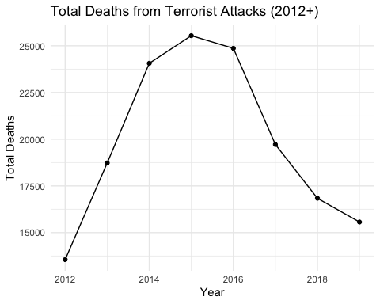
ggplot(byyear_stats, aes(x = iyear, y= avg_injuries)) +
geom_line() +
geom_point() +
labs(
title = "Average Injuries from Terrorist Attacks (2012+)",
x = "Year",
y = "Average Injuries"
) +
theme_minimal()
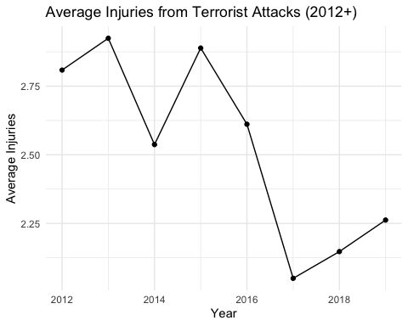
ggplot(byyear_stats, aes(x = iyear, y= avg_deaths)) +
geom_line() +
geom_point() +
labs(
title = "Average Deaths from Terrorist Attacks (2012+)",
x = "Year",
y = "Average Deaths"
) +
theme_minimal()
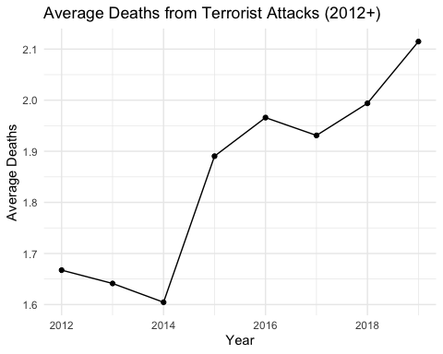
gtdclean <- gtdclean %>%
mutate(region_name = case_when(
region == 1 ~ "North America",
region == 2 ~ "Central America & Caribbean",
region == 3 ~ "South America",
region == 4 ~ "East Asia",
region == 5 ~ "Southeast Asia",
region == 6 ~ "South Asia",
region == 7 ~ "Central Asia",
region == 8 ~ "Western Europe",
region == 9 ~ "Eastern Europe",
region == 10 ~ "Middle East & North Africa",
region == 11 ~ "Sub-Saharan Africa",
region == 12 ~ "Australasia & Oceania",
TRUE ~ "Other"
))
region_year_stats <- gtdclean %>%
filter(iyear >= 2012) %>%
group_by(iyear, region_name) %>%
summarise(
total_deaths = sum(nkill, na.rm = TRUE),
avg_deaths = mean(nkill, na.rm = TRUE),
avg_injuries = mean(nwound, na.rm = TRUE),
n_attacks = n(),
.groups = "drop"
)
region_plot1 <- region_year_stats %>%
filter(region_name %in% c(
"North America",
"Central America & Caribbean",
"South America",
"East Asia",
"Southeast Asia",
"South Asia"
))
region_plot2 <- region_year_stats %>%
filter(region_name %in% c(
"Central Asia",
"Western Europe",
"Eastern Europe",
"Middle East & North Africa",
"Sub-Saharan Africa",
"Australasia & Oceania"
))
# Average Deaths Plots
ggplot(region_plot1, aes(x = iyear, y = avg_deaths, color = region_name)) +
geom_line() +
labs(title = "Terrorism Average Deaths (Regions Group 1)") +
theme(legend.text = element_text(size = 6))
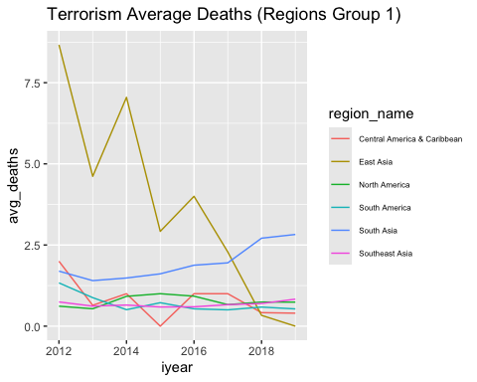
ggplot(region_plot2, aes(x = iyear, y = avg_deaths, color = region_name)) +
geom_line() +
labs(title = "Terrorism Average Deaths (Regions Group 2)") +
theme(legend.text = element_text(size = 6))
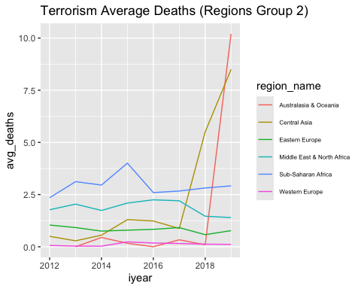
#Average Injuries Plots
ggplot(region_plot1, aes(x = iyear, y = avg_injuries, color = region_name)) +
geom_line() +
labs(title = "Terrorism Average Injuries (Regions Group 1)") +
theme(legend.text = element_text(size = 6))
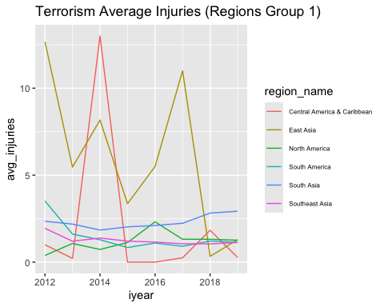
ggplot(region_plot2, aes(x = iyear, y = avg_injuries, color = region_name)) +
geom_line() +
labs(title = "Terrorism Average Injuries (Regions Group 2)") +
theme(legend.text = element_text(size = 6))
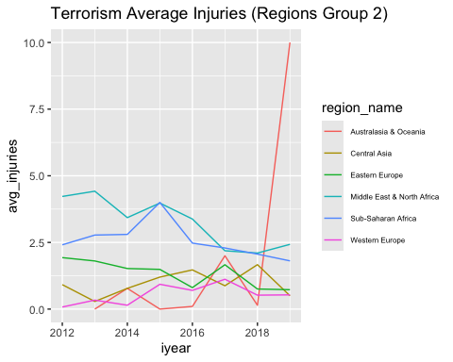
#Attack frequency
ggplot(region_plot1, aes(x = iyear, y = n_attacks, color = region_name)) +
geom_line() +
labs(title = "Attack Frequency (Regions Group 1)") +
theme(legend.text = element_text(size = 6))
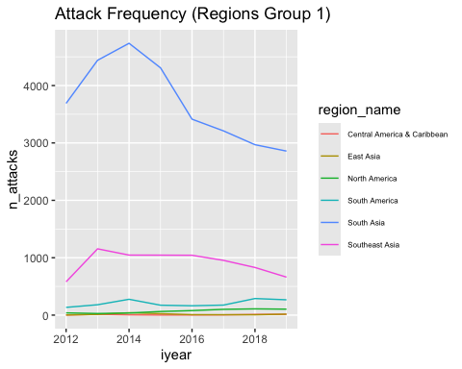
ggplot(region_plot2, aes(x = iyear, y = n_attacks, color = region_name)) +
geom_line() +
labs(title = "Attack Frequency (Regions Group 2)") +
theme(legend.text = element_text(size = 6))
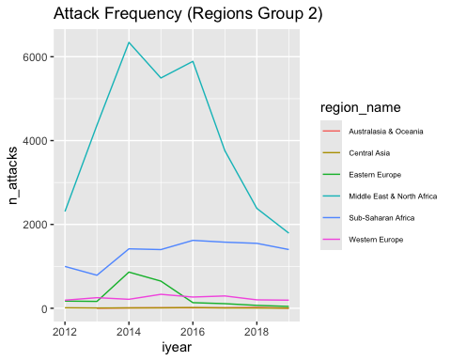
# Attack frequency (only general categories)
ggplot(gtd_data, aes(x = reorder(attacktype1_txt, attacktype1_txt, length))) +
geom_bar() +
coord_flip() +
labs(
title = "Frequency of Attack Types",
x = "Attack Type",
y = "Count"
) +
theme_minimal()
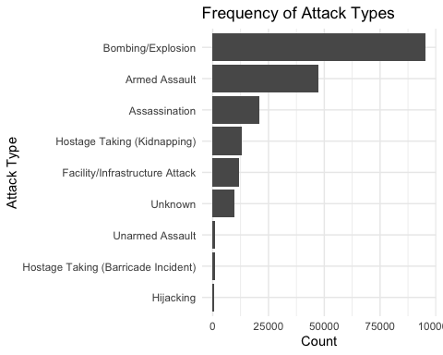
# Weapon types
top_weapons <- gtdclean %>%
count(weaptype1_txt, sort = TRUE) %>%
slice_head(n = 10)
top_weapons <- gtdclean %>%
mutate(weaptype1_txt = ifelse(
weaptype1_txt == "Vehicle (not to include vehicle-borne explosives, i.e., car or truck bombs)",
"Vehicle",
weaptype1_txt
)) %>%
count(weaptype1_txt, sort = TRUE) %>%
slice_head(n = 10)
ggplot(top_weapons, aes(x = reorder(weaptype1_txt, n), y = n)) +
geom_col() +
coord_flip() +
labs(
title = "Top 10 Weapon Types",
x = "Weapon Type",
y = "Number of Attacks"
) +
theme_minimal()
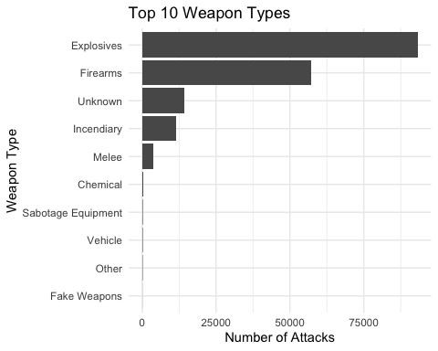
attack_severity <- gtdclean %>%
group_by(attacktype1_txt) %>%
summarise(avg_deaths = mean(nkill, na.rm = TRUE)) %>%
arrange(desc(avg_deaths)) %>%
slice_head(n = 10)
ggplot(attack_severity, aes(x = reorder(attacktype1_txt, avg_deaths), y = avg_deaths)) +
geom_col() +
coord_flip() +
labs(
title = "Most Lethal Attack Types (Avg Deaths)",
x = "Attack Type",
y = "Average Deaths"
) +
theme_minimal()
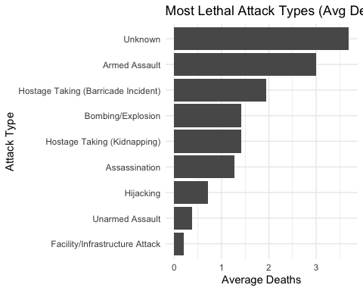
#Modeling
gtd_mod2 <- gtdclean %>%
mutate(severity_index = 2 * nkill + nwound) %>%
select(
attacktype1_txt,
weaptype1_txt,
targtype1_txt,
region_txt,
success,
severity_index,
multiple,
claimed,
ishostkid,
ransom,
extended
) %>%
drop_na() %>%
mutate(across(c(attacktype1_txt, weaptype1_txt,
targtype1_txt, region_txt), as.factor))
set.seed(123)
train_index <- createDataPartition(gtd_mod2$severity_index, p = 0.7, list = FALSE)
train <- gtd_mod2[train_index, ]
test <- gtd_mod2[-train_index, ]
# Linear Regression
lm_mod <- lm(severity_index ~ ., data = train)
summary(lm_mod)
##
## Call:
## lm(formula = severity_index ~ ., data = train)
##
## Residuals:
## Min 1Q Median 3Q Max
## -43.518 -3.786 -1.700 0.482 148.995
##
## Coefficients:
## Estimate
## (Intercept) 5.555364
## attacktype1_txtAssassination -4.307744
## attacktype1_txtBombing/Explosion -17.286178
## attacktype1_txtFacility/Infrastructure Attack -4.615918
## attacktype1_txtHijacking -5.940351
## attacktype1_txtHostage Taking (Barricade Incident) -1.459493
## attacktype1_txtHostage Taking (Kidnapping) -4.900527
## attacktype1_txtUnarmed Assault -5.308418
## attacktype1_txtUnknown 0.092408
## weaptype1_txtChemical -0.002711
## weaptype1_txtExplosives 11.025555
## weaptype1_txtFake Weapons -2.419160
## weaptype1_txtFirearms -4.780907
## weaptype1_txtIncendiary -3.297758
## weaptype1_txtMelee -4.352588
## weaptype1_txtOther -3.516254
## weaptype1_txtRadiological -27.491923
## weaptype1_txtSabotage Equipment -2.937012
## weaptype1_txtUnknown -6.472682
## weaptype1_txtVehicle (not to include vehicle-borne explosives, i.e., car or truck bombs) 45.207813
## targtype1_txtAirports & Aircraft -1.610991
## targtype1_txtBusiness -0.565035
## targtype1_txtEducational Institution -1.322108
## targtype1_txtFood or Water Supply 2.308276
## targtype1_txtGovernment (Diplomatic) -3.374113
## targtype1_txtGovernment (General) -0.849333
## targtype1_txtJournalists & Media -2.158623
## targtype1_txtMaritime -2.648971
## targtype1_txtMilitary 3.362421
## targtype1_txtNGO -1.487078
## targtype1_txtOther -3.729457
## targtype1_txtPolice 1.637157
## targtype1_txtPrivate Citizens & Property 1.232658
## targtype1_txtReligious Figures/Institutions -1.039723
## targtype1_txtTelecommunication -4.992727
## targtype1_txtTerrorists/Non-State Militia 6.181684
## targtype1_txtTourists -2.630343
## targtype1_txtTransportation -0.185865
## targtype1_txtUnknown -1.701209
## targtype1_txtUtilities -2.604790
## targtype1_txtViolent Political Party -1.601764
## region_txtCentral America & Caribbean -1.419790
## region_txtCentral Asia 1.451542
## region_txtEast Asia 25.922728
## region_txtEastern Europe 1.617415
## region_txtMiddle East & North Africa 3.340309
## region_txtNorth America -0.073931
## region_txtSouth America 0.586065
## region_txtSouth Asia 2.203374
## region_txtSoutheast Asia 0.130544
## region_txtSub-Saharan Africa 4.787293
## region_txtWestern Europe -0.512252
## success 2.257485
## multiple 2.171581
## claimed 0.418833
## ishostkid 2.652933
## ransom 0.037690
## extended 0.133111
## Std. Error
## (Intercept) 12.210864
## attacktype1_txtAssassination 0.891963
## attacktype1_txtBombing/Explosion 1.022911
## attacktype1_txtFacility/Infrastructure Attack 1.285638
## attacktype1_txtHijacking 1.228146
## attacktype1_txtHostage Taking (Barricade Incident) 0.894665
## attacktype1_txtHostage Taking (Kidnapping) 0.656671
## attacktype1_txtUnarmed Assault 3.043096
## attacktype1_txtUnknown 1.813233
## weaptype1_txtChemical 10.673573
## weaptype1_txtExplosives 10.824973
## weaptype1_txtFake Weapons 11.824349
## weaptype1_txtFirearms 10.799763
## weaptype1_txtIncendiary 10.818455
## weaptype1_txtMelee 10.805729
## weaptype1_txtOther 10.769118
## weaptype1_txtRadiological 12.589825
## weaptype1_txtSabotage Equipment 11.335025
## weaptype1_txtUnknown 10.801896
## weaptype1_txtVehicle (not to include vehicle-borne explosives, i.e., car or truck bombs) 13.062494
## targtype1_txtAirports & Aircraft 2.248125
## targtype1_txtBusiness 1.085463
## targtype1_txtEducational Institution 1.193191
## targtype1_txtFood or Water Supply 3.654657
## targtype1_txtGovernment (Diplomatic) 1.437089
## targtype1_txtGovernment (General) 1.113073
## targtype1_txtJournalists & Media 1.264718
## targtype1_txtMaritime 2.038906
## targtype1_txtMilitary 1.140497
## targtype1_txtNGO 1.299684
## targtype1_txtOther 4.380611
## targtype1_txtPolice 1.144342
## targtype1_txtPrivate Citizens & Property 1.086869
## targtype1_txtReligious Figures/Institutions 1.369642
## targtype1_txtTelecommunication 2.540242
## targtype1_txtTerrorists/Non-State Militia 1.457491
## targtype1_txtTourists 1.788616
## targtype1_txtTransportation 1.550776
## targtype1_txtUnknown 2.350344
## targtype1_txtUtilities 1.928720
## targtype1_txtViolent Political Party 1.694890
## region_txtCentral America & Caribbean 7.963313
## region_txtCentral Asia 5.734951
## region_txtEast Asia 7.968386
## region_txtEastern Europe 5.314227
## region_txtMiddle East & North Africa 5.247161
## region_txtNorth America 5.275008
## region_txtSouth America 5.269992
## region_txtSouth Asia 5.244549
## region_txtSoutheast Asia 5.262515
## region_txtSub-Saharan Africa 5.249557
## region_txtWestern Europe 5.375420
## success 0.762269
## multiple 0.425201
## claimed 0.138426
## ishostkid 0.758137
## ransom 0.044157
## extended 0.311389
## t value
## (Intercept) 0.455
## attacktype1_txtAssassination -4.830
## attacktype1_txtBombing/Explosion -16.899
## attacktype1_txtFacility/Infrastructure Attack -3.590
## attacktype1_txtHijacking -4.837
## attacktype1_txtHostage Taking (Barricade Incident) -1.631
## attacktype1_txtHostage Taking (Kidnapping) -7.463
## attacktype1_txtUnarmed Assault -1.744
## attacktype1_txtUnknown 0.051
## weaptype1_txtChemical 0.000
## weaptype1_txtExplosives 1.019
## weaptype1_txtFake Weapons -0.205
## weaptype1_txtFirearms -0.443
## weaptype1_txtIncendiary -0.305
## weaptype1_txtMelee -0.403
## weaptype1_txtOther -0.327
## weaptype1_txtRadiological -2.184
## weaptype1_txtSabotage Equipment -0.259
## weaptype1_txtUnknown -0.599
## weaptype1_txtVehicle (not to include vehicle-borne explosives, i.e., car or truck bombs) 3.461
## targtype1_txtAirports & Aircraft -0.717
## targtype1_txtBusiness -0.521
## targtype1_txtEducational Institution -1.108
## targtype1_txtFood or Water Supply 0.632
## targtype1_txtGovernment (Diplomatic) -2.348
## targtype1_txtGovernment (General) -0.763
## targtype1_txtJournalists & Media -1.707
## targtype1_txtMaritime -1.299
## targtype1_txtMilitary 2.948
## targtype1_txtNGO -1.144
## targtype1_txtOther -0.851
## targtype1_txtPolice 1.431
## targtype1_txtPrivate Citizens & Property 1.134
## targtype1_txtReligious Figures/Institutions -0.759
## targtype1_txtTelecommunication -1.965
## targtype1_txtTerrorists/Non-State Militia 4.241
## targtype1_txtTourists -1.471
## targtype1_txtTransportation -0.120
## targtype1_txtUnknown -0.724
## targtype1_txtUtilities -1.351
## targtype1_txtViolent Political Party -0.945
## region_txtCentral America & Caribbean -0.178
## region_txtCentral Asia 0.253
## region_txtEast Asia 3.253
## region_txtEastern Europe 0.304
## region_txtMiddle East & North Africa 0.637
## region_txtNorth America -0.014
## region_txtSouth America 0.111
## region_txtSouth Asia 0.420
## region_txtSoutheast Asia 0.025
## region_txtSub-Saharan Africa 0.912
## region_txtWestern Europe -0.095
## success 2.962
## multiple 5.107
## claimed 3.026
## ishostkid 3.499
## ransom 0.854
## extended 0.427
## Pr(>|t|)
## (Intercept) 0.649158
## attacktype1_txtAssassination 1.40e-06
## attacktype1_txtBombing/Explosion < 2e-16
## attacktype1_txtFacility/Infrastructure Attack 0.000333
## attacktype1_txtHijacking 1.35e-06
## attacktype1_txtHostage Taking (Barricade Incident) 0.102868
## attacktype1_txtHostage Taking (Kidnapping) 9.55e-14
## attacktype1_txtUnarmed Assault 0.081133
## attacktype1_txtUnknown 0.959356
## weaptype1_txtChemical 0.999797
## weaptype1_txtExplosives 0.308463
## weaptype1_txtFake Weapons 0.837898
## weaptype1_txtFirearms 0.658007
## weaptype1_txtIncendiary 0.760507
## weaptype1_txtMelee 0.687105
## weaptype1_txtOther 0.744047
## weaptype1_txtRadiological 0.029022
## weaptype1_txtSabotage Equipment 0.795559
## weaptype1_txtUnknown 0.549048
## weaptype1_txtVehicle (not to include vehicle-borne explosives, i.e., car or truck bombs) 0.000542
## targtype1_txtAirports & Aircraft 0.473650
## targtype1_txtBusiness 0.602700
## targtype1_txtEducational Institution 0.267882
## targtype1_txtFood or Water Supply 0.527671
## targtype1_txtGovernment (Diplomatic) 0.018909
## targtype1_txtGovernment (General) 0.445459
## targtype1_txtJournalists & Media 0.087905
## targtype1_txtMaritime 0.193916
## targtype1_txtMilitary 0.003207
## targtype1_txtNGO 0.252588
## targtype1_txtOther 0.394602
## targtype1_txtPolice 0.152576
## targtype1_txtPrivate Citizens & Property 0.256778
## targtype1_txtReligious Figures/Institutions 0.447807
## targtype1_txtTelecommunication 0.049403
## targtype1_txtTerrorists/Non-State Militia 2.25e-05
## targtype1_txtTourists 0.141445
## targtype1_txtTransportation 0.904603
## targtype1_txtUnknown 0.469206
## targtype1_txtUtilities 0.176892
## targtype1_txtViolent Political Party 0.344665
## region_txtCentral America & Caribbean 0.858500
## region_txtCentral Asia 0.800195
## region_txtEast Asia 0.001147
## region_txtEastern Europe 0.760866
## region_txtMiddle East & North Africa 0.524411
## region_txtNorth America 0.988818
## region_txtSouth America 0.911455
## region_txtSouth Asia 0.674407
## region_txtSoutheast Asia 0.980210
## region_txtSub-Saharan Africa 0.361832
## region_txtWestern Europe 0.924083
## success 0.003072
## multiple 3.36e-07
## claimed 0.002490
## ishostkid 0.000470
## ransom 0.393386
## extended 0.669048
##
## (Intercept)
## attacktype1_txtAssassination ***
## attacktype1_txtBombing/Explosion ***
## attacktype1_txtFacility/Infrastructure Attack ***
## attacktype1_txtHijacking ***
## attacktype1_txtHostage Taking (Barricade Incident)
## attacktype1_txtHostage Taking (Kidnapping) ***
## attacktype1_txtUnarmed Assault .
## attacktype1_txtUnknown
## weaptype1_txtChemical
## weaptype1_txtExplosives
## weaptype1_txtFake Weapons
## weaptype1_txtFirearms
## weaptype1_txtIncendiary
## weaptype1_txtMelee
## weaptype1_txtOther
## weaptype1_txtRadiological *
## weaptype1_txtSabotage Equipment
## weaptype1_txtUnknown
## weaptype1_txtVehicle (not to include vehicle-borne explosives, i.e., car or truck bombs) ***
## targtype1_txtAirports & Aircraft
## targtype1_txtBusiness
## targtype1_txtEducational Institution
## targtype1_txtFood or Water Supply
## targtype1_txtGovernment (Diplomatic) *
## targtype1_txtGovernment (General)
## targtype1_txtJournalists & Media .
## targtype1_txtMaritime
## targtype1_txtMilitary **
## targtype1_txtNGO
## targtype1_txtOther
## targtype1_txtPolice
## targtype1_txtPrivate Citizens & Property
## targtype1_txtReligious Figures/Institutions
## targtype1_txtTelecommunication *
## targtype1_txtTerrorists/Non-State Militia ***
## targtype1_txtTourists
## targtype1_txtTransportation
## targtype1_txtUnknown
## targtype1_txtUtilities
## targtype1_txtViolent Political Party
## region_txtCentral America & Caribbean
## region_txtCentral Asia
## region_txtEast Asia **
## region_txtEastern Europe
## region_txtMiddle East & North Africa
## region_txtNorth America
## region_txtSouth America
## region_txtSouth Asia
## region_txtSoutheast Asia
## region_txtSub-Saharan Africa
## region_txtWestern Europe
## success **
## multiple ***
## claimed **
## ishostkid ***
## ransom
## extended
## ---
## Signif. codes: 0 '***' 0.001 '**' 0.01 '*' 0.05 '.' 0.1 ' ' 1
##
## Residual standard error: 10.36 on 6721 degrees of freedom
## Multiple R-squared: 0.1562, Adjusted R-squared: 0.149
## F-statistic: 21.83 on 57 and 6721 DF, p-value: < 2.2e-16
lm_pred <- predict(lm_mod, test)
lm_rmse <- RMSE(lm_pred, test$severity_index)
lm_r2 <- R2(lm_pred, test$severity_index)
cat("Linear Regression — RMSE:", lm_rmse, " R²:", lm_r2, "\n")
## Linear Regression — RMSE: 11.23059 R²: 0.143081
# Ridge and Lasso
library(glmnet)
## Loading required package: Matrix
##
## Attaching package: 'Matrix'
##
## The following objects are masked from 'package:tidyr':
##
## expand, pack, unpack
##
## Loaded glmnet 4.1-10
# Build matrices
x_train <- model.matrix(severity_index ~ ., data = train)[, -1]
y_train <- train$severity_index
x_test <- model.matrix(severity_index ~ ., data = test)[, -1]
y_test <- test$severity_index
# Ridge (alpha = 0) — finds best lambda automatically via cross-validation
ridge_cv <- cv.glmnet(x_train, y_train, alpha = 0)
ridge_pred <- predict(ridge_cv, s = "lambda.min", newx = x_test)
ridge_rmse <- RMSE(as.vector(ridge_pred), y_test)
ridge_r2 <- R2(as.vector(ridge_pred), y_test)
cat("Ridge — RMSE:", ridge_rmse, " R²:", ridge_r2, "\n")
## Ridge — RMSE: 11.22811 R²: 0.1436415
# Lasso (alpha = 1) — also shrinks some coefficients to exactly zero
lasso_cv <- cv.glmnet(x_train, y_train, alpha = 1)
lasso_pred <- predict(lasso_cv, s = "lambda.min", newx = x_test)
lasso_rmse <- RMSE(as.vector(lasso_pred), y_test)
lasso_r2 <- R2(as.vector(lasso_pred), y_test)
cat("Lasso — RMSE:", lasso_rmse, " R²:", lasso_r2, "\n")
## Lasso — RMSE: 11.23 R²: 0.1439644
# Random Forest
# library(randomForest)
# rf_model <- randomForest(severity_index ~ ., data = train, importance = TRUE)
# rf_pred <- predict(rf_model, test)
# rf_rmse <- RMSE(rf_pred, test$severity_index)
# rf_r2 <- R2(rf_pred, test$severity_index)
# cat("Random Forest — RMSE:", rf_rmse, " R²:", rf_r2, "\n")
# Results
results <- data.frame(
Model = c("Linear Regression", "Ridge", "Lasso"),
RMSE = c(lm_rmse, ridge_rmse, lasso_rmse),
R2 = c(lm_r2, ridge_r2, lasso_r2)
) %>%
arrange(RMSE) # best model at top
knitr::kable(results, digits = 3, caption = "Model Comparison: Predicting Severity Index")

Model Comparison: Predicting Severity Index
Model | RMSE | R2
Ridge | 11.228 | 0.144
Lasso | 11.230 | 0.144
Linear Regression | 11.231 | 0.143

